

Submitted by : Spogmai Jan

Roll No : 2430 – 0081

Submitted To : Sir Bilal Dar

Subject : Digital logic design

Lab task 02

#### Question: Implement all the logic gates and verify their truth tables.

**Note: Make Truth Tables for all logic gates as shown in the below. AND, OR, NOT, NAND, NOR, EX-OR, EX_NOR.**

**And Gate :**

|  |  |  |
| --- | --- | --- |
| **A** | **B** | **A^B** |
| **0** | **0** | **0** |
| **0** | **1** | **0** |
| **1** | **0** | **0** |
| **1** | **1** | **1** |

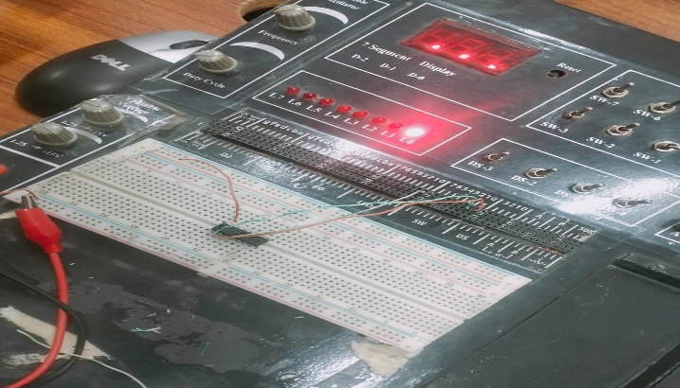

**OR gate :**

|  |  |  |
| --- | --- | --- |
| **A** | **B** | **AvB** |
| **0** | **0** | **0** |
| **0** | **1** | **1** |
| **1** | **0** | **1** |
| **1** | **1** | **1** |

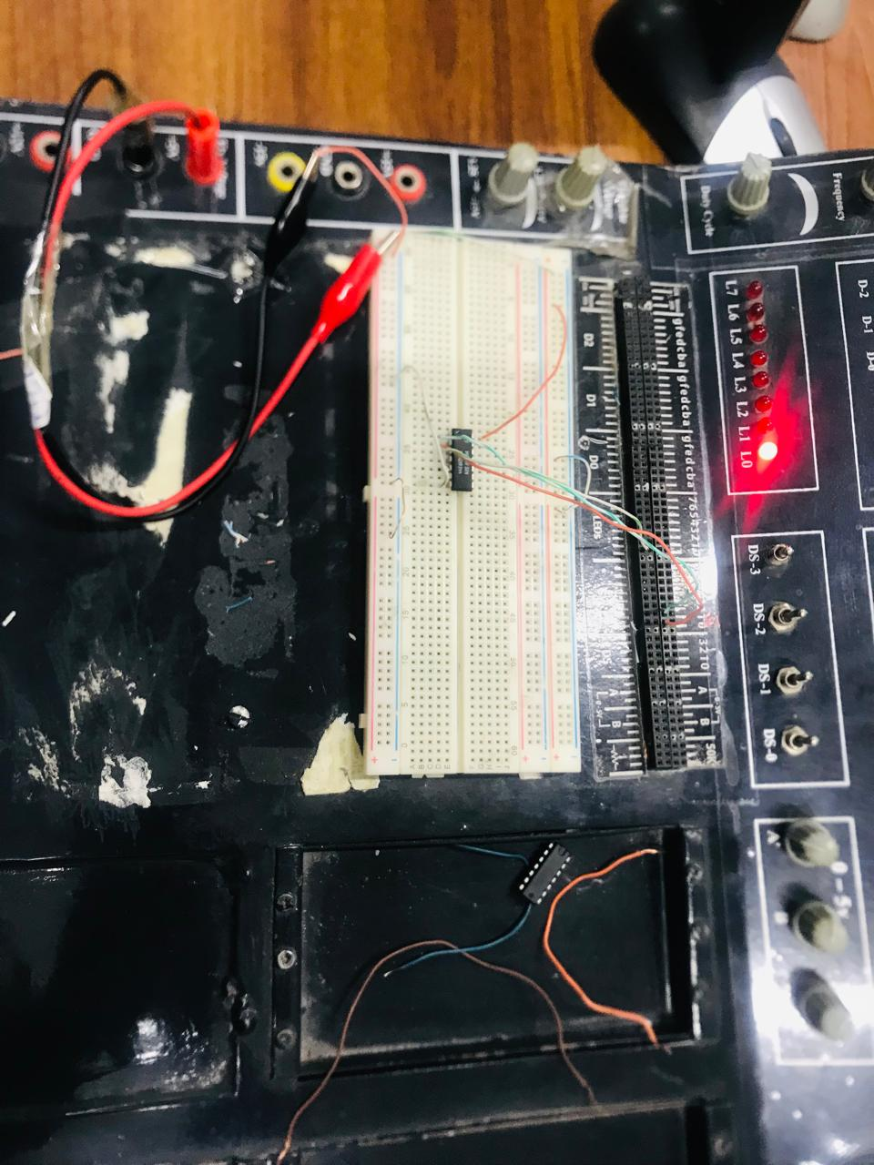

**Nand gate :**

|  |  |  |  |
| --- | --- | --- | --- |
| **A** | **B** | **A^B** | **A nand B** |
| **0** | **0** | **0** | **1** |
| **0** | **1** | **0** | **1** |
| **1** | **0** | **0** | **1** |
| **1** | **1** | **1** | **0** |

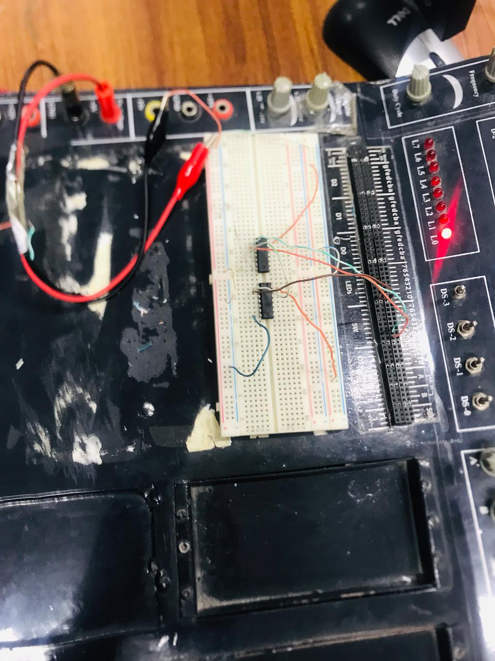

**Nor gate :**

|  |  |  |  |
| --- | --- | --- | --- |
| **A** | **B** | **AvB** | **A nor B** |
| **0** | **0** | **0** | **1** |
| **0** | **1** | **1** | **0** |
| **1** | **0** | **1** | **0** |
| **1** | **1** | **1** | **0** |

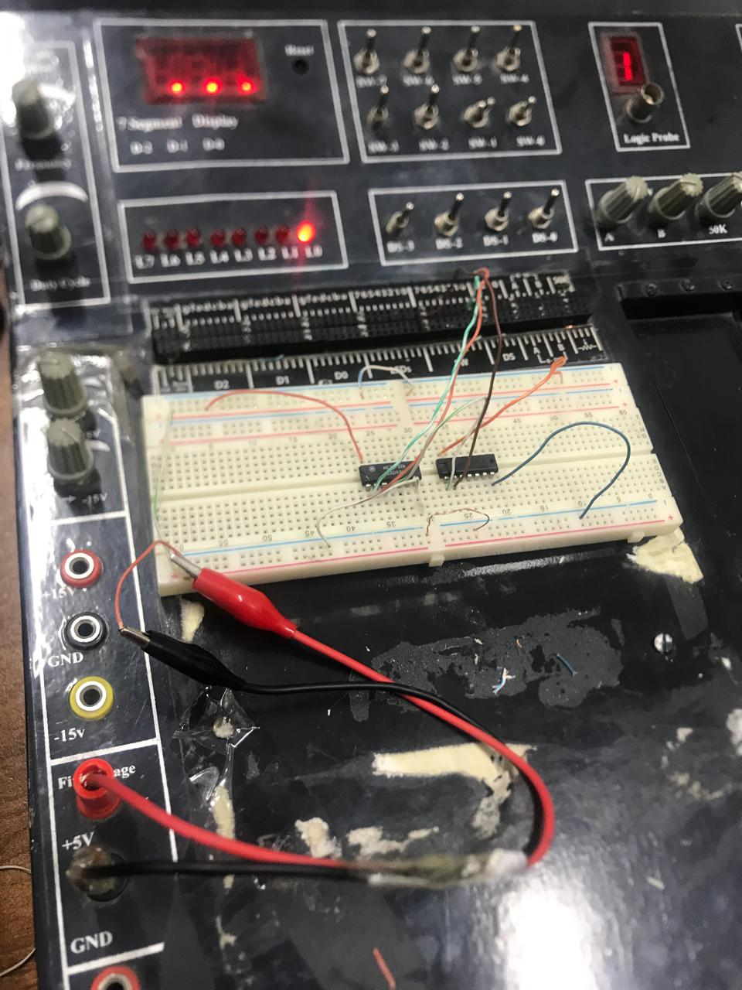

**Not gate :**

|  |  |
| --- | --- |
| **A** | **Not A** |
| **0** | **1** |
| **1** | **0** |

**----- THE END -----**